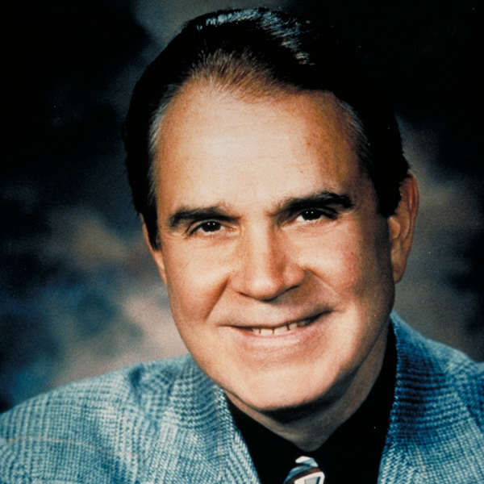
Rich Little
Legendary Impressionist and Comedian
US Presidents: John F. Kennedy, Lyndon Johnson, Richard Nixon, Gerald Ford, Jimmy Carter, Ronald Reagan, Bill Clinton, both George Bushes...Rich Little has an impression of each of them.
Infamous for his skewing of political figures, Little has charmed, amused, annoyed, and lampooned politicians from here to his native Canada. He entertained at the Reagan inaugurals and spent much of 2003 touring the United States with his show, The Presidents.
A master mimic of over 200 voices, Little continues to impress in Atlantic City, Las Vegas, Reno, Hawaii, Chicago, New York, and London.
A professed classic movie buff, he's particularly fond of doing Alan Ladd (his hero as a kid) and others who are no longer generally remembered, but Little has also latched on to Baby Boomer-friendly characters like Edith Bunker, Kermit the Frog, Robin Leach, and Dr. Ruth Westheimer, just to name a few.
Some of his favorite current stars are Arnold Schwarzenegger, Sylvester Stallone, Jack Nicholson, and Clint Eastwood. "They're easy to do," he says. "They are larger than life."
Little says, "an impression is what you think a person sounds like. It could be an exaggeration or a cartoon. It's your impression. I think of an impersonation as more of an exact copy. Knowing the person personally is not important; it's knowing the speech patterns and mannerisms [in order] to imitate the person the way the public sees him." It took him seven years to perfect Frank Sinatra, but only several minutes to mimic Dr. Ruth.
The son of a doctor in Ottawa, Canada, Little started his "career" at the age of 12 when he answered back to his teachers in their own voices. Observing the teachers in action was infinitely more fun than paying attention to classwork. To get dates, he'd find out the girl's favorite actor, then call her up imitating that actor's voice. Then when Little showed up, he'd say, "Sorry, Cary can't make it."
Little's first appearances were in a small club in Canada. "I got booked into this place in Quebec, and when I started my act, I discovered that no one in the audience understood English. It was strictly a French-speaking audience." He figured he was dead until an inspiration hit him. "I did walks . . . Jack Benny's walk, Bob Hope's walk, John Wayne's walk. They all walk the same in French as in English," he recalls.
While working as a disc jockey and talk show host, for one April Fools Day marathon he had "Jimmy Durante" emcee the morning show; "James Mason" was a rock 'n' roll deejay; and "Elvis Presley" hosted an afternoon program. Like the infamous 1939 broadcast of War of the Worlds, 500 autograph-hungry Elvis-believing fans besieged the station, thinking the King was really there.
While still in his early 20's, Little was "discovered" in the United States. His friend, singer Mel Torme, then on the musical team of CBS' The Judy Garland Show, asked him to make a tape. Instead of the usual impressions, he did Fred MacMurray, Dana Andrews, James Mason and Van Heflin, "the kinds of people nobody did." Garland thought it was "great" and Little was signed for the show.
Appearances on TV variety shows starring Ed Sullivan, Jackie Gleason, Glen Campbell, and Dean Martin followed, as well as on such series as Laugh-In, The John Davidson Summer Show, and The Julie Andrews Show. Little had his own variety show in the 70's. He also was an early guest host on that TV staple, The Tonight Show, hosting 12 times. He was the star of the TV show KopyKats. Rich Little became a household name sitting in one of the Hollywood Squares and has also appeared on the Oak Ridge Boys Variety Special.
He was named "Comedy Star of the Year" by the American Guild of Variety Artists. The perpetrator of nine comedy albums and three HBO comedy specials, Rich Little's Christmas Carol with "W.C. Fields" as Scrooge, "Humphrey Bogart" as one of the ghosts and "Paul Lynde" as Bob Cratchit won an Emmy, among other awards.
His latest appearance on HBO was as Johnny Carson in the movie The Late Shift, which dealt with the race to succeed Carson on The Tonight Show. Little has appeared on the daytime soaps The Young and the Restless and Santa Barbara. He has made dramatic guest shots on Fantasy Island, CHIPS, Murder She Wrote, Hawaii Five-O, MacGyver, Police Woman, and Mannix.
In a GQ fashion spread, Little was pictured as Richard Nixon, Jack Nicholson, Cary Grant, George Burns, Ronald Reagan and Humphrey Bogart. In an Oscar pre-cast of ABC's Primetime (with Diane Sawyer and Sam Donaldson) he spoofed classic movies, proposing how they would end with different casts, starring Little as "Bette Midler" as Scarlett O'Hara and "Arnold Schwarzenegger" as Hamlet.
Little's expert impressions have also been used seriously, as when he stepped in for stars who were unable to do their own redubbings on soundtracks. David Niven's vocal cords were gone due to illness in his last film, Curse of the Pink Panther. Peter Sellers himself was gone by the end of The Trail of the Pink Panther. Little provided both voices for these films. The TV series Mickey Spillane's Mike Hammer needed voice-over narrations on three shows, but star Stacey Keach was unable to finish them. Rich Little was called in to finish the job. He also did Gene Kelly for a Christmas special when Kelly lost his voice.
His greatest fear? A sore throat. "Other people get a cold, and they just get a cold. I get a cold and John Wayne gets a cold, Orson Welles gets a cold, Nixon gets a cold, Truman Capote gets a cold. No correction, Truman gets the sniffles. I get a cold and it's all over."
Over the years Rich Little has been active with children's charities and he was co-host of the Canadian division of the Children's Miracle Network. He was inducted into the Miami Children's Hospital International Pediatrics Hall of Fame for his tireless efforts in fundraising on behalf of children. In June of 1998 Rich Little added his star to the Canadian Walk of Fame to go along with his current star on the Hollywood Walk of Fame.
Though still a Canadian citizen, Little lives in Las Vegas with his wife Marie. He has two daughters, who ride horses and cheerlead full-time. (And, oh yeah, don't forget about the two cats!)

