
________________________________________________________________________

B i o g r a p h y

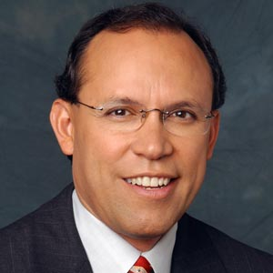
MANNY MEDRANO

Former ABC News Supreme Court/Legal Affairs Correspondent and Former Federal Prosecutor

As the former Supreme Court/Legal Affairs Correspondent for ABC News, Manuel Medrano has covered some of the most important national news stories of the past decade. With a front row seat to news events, Medrano has unique insight into stories that have changed the fabric and landscape of our society. He covers the Supreme Court and provides legal analysis for all ABC News broadcasts.

Mr. Medrano moved to ABC News in 2004 from K-NBC in Los Angeles, where he was a general assignment reporter, focusing on legal issues for NBC4's Channel 4 News. There he provided legal analysis and commentary for the station's comprehensive coverage of the trials of OJ Simpson, the Menendez Brothers, Reginald Denny and Rodney King, among others. In 1995 his coverage of the Simpson case earned him an Emmy Award and Golden Mike Award.

Prior to joining K-NBC, Mr. Medrano was a federal criminal prosecutor who never lost a jury trial. At the law firm of Sonnenschein, Nath & Rosenthal in Los Angeles, he specialized in complex civil and white collar criminal litigation. He also served as an Assistant US Attorney for the Los Angeles US Attorney's Office, where he braved death threats to successfully prosecute the drug cartel leaders that kidnapped, tortured and murdered DEA federal drug agent Enrique Camarena. Medrano is the recipient of numerous awards and honors for his trial lawyer achievements. In 1992 he received the US Department of US Justice Award for his performance on the Camarena case.

Since 1988, Mr. Medrano has served as an Adjunct Professor of Law at Loyola Law School, the University of Southern California Law School, Pepperdine University School of Law and Southwestern University School of Law. He is a graduate of Harvard College and Harvard Law School.

Currently, Mr. Medrano is an anchor and correspondent with KTLA in Southern California.

Fluent in Spanish, Mr. Medrano is actively involved in numerous charitable organizations. A native of Texas, he resides in the Washington, DC area, and was named to Hispanic Business Magazine’s “100 Influentials List 2005”. Mr. Medrano is also a professional speaker who has spoken to corporations, non-profits, government agencies and universities across the country. An embodiment of the American success story, Medrano’s personal journey has taken him from a gang-infested barrio to the pinnacle of journalism as an Emmy-award winning network correspondent.

