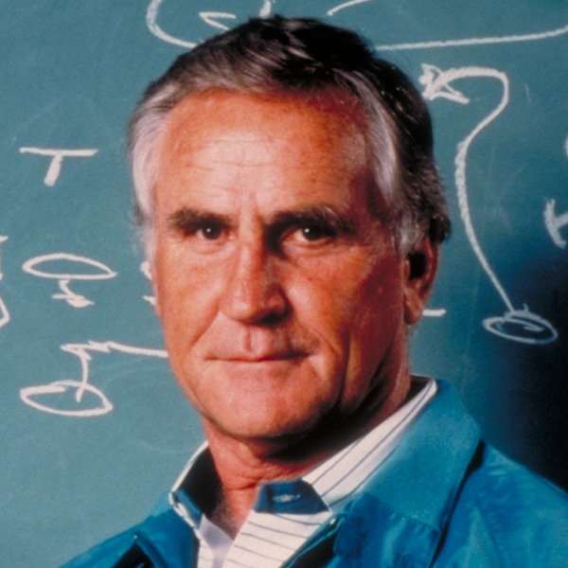
Don Shula
NFL Hall of Fame Head Coach

On July 26, 1997, Don Shula capped an illustrious career when he was inducted into the Pro Football Hall of Fame. His unanimous election to the Hall was the ultimate honor in a career full of record-setting accomplishments.
Shula broke into the NFL as the lone rookie on Coach Paul Brown's defending NFL champion Cleveland Browns in 1951. He was involved in the largest trade in modern NFL history, a 15-player deal with Baltimore in 1953, and he played four seasons with the Colts (1953-56) and one season at Washington (1957) at right cornerback. He had 21 career interceptions for 247 yards in seven seasons. In college, he was a running back at John Carroll University in Cleveland.
After serving for three years (1960-1962) as defensive coordinator of the Detroit Lions, he became head coach in Baltimore. Shula entered the coaching ranks with an assistant's job at Virginia (1958) and Kentucky (1959) before joining the Lions.
Shula spent seven years as head coach of the Baltimore Colts. In that span, he complied a record 73-26-4 (.728) and advanced to the playoffs four times, including two appearances in the NFL Championship Game, in 1964 and 1968. At age 33, he was the youngest head coach in the history of the NFL.
Shula's record as head coach of the Dolphins (1970-96) and the Baltimore Colts (1963-69) is unmatched in National Football League history. He has appeared in more Super Bowls than any other coach beginning with the Colts in 1968. Along with being one of only two coaches to reach the Super Bowl three straight seasons (1971-73), he is only one of five coaches in NFL history to win consecutive Super Bowls (1972 and 1973). He also advanced to the Bowl with the Dolphins in 1982 and 1984.
A remarkable 20 times in 33 seasons, Shula's teams reached the playoffs. In that span, he suffered only two losing seasons. On November 14, 1993, in Philadelphia, Shula won his 325th career game, moving him past the immortal George Halas (324-151-31) and setting an NFL record for most career victories.
Starting with the 1996 season, Don served as vice-chairman of the Miami Dolphins. He also contributed to the growth of the NFL off the field by serving from 1975 through 1995 on the league's influential Competition Committee.
Along with his football responsibilities, Shula has always offered considerable time and support to many charities. The Don Shula Foundation, formed primarily to assist breast cancer research, was established as a tribute to his late wife, Dorothy.
A member of the class of 1951 at John Carroll, Shula helped fund a $1 million charity in the University's Department of Philosophy. To show their appreciation, John Carroll University named their athletic complex The Don Shula Sports Center.
Because of his success on the football field and his long-time civic and charitable service, Shula has received countless prestigious awards, including the 1993 Sports Illustrated Sportsman of the Year Award.
In addition, he co-authored Everyone's A Coach (1995) with Ken Blanchard. This highly acclaimed book outlines the application of their managerial philosophies for business and personal success. Shula personifies those business principles himself, serving as an equity partner in two highly successful enterprises, Don Shula's Hotel & Golf Club and Don Shula's Steak Houses, Inc.

